

SIMATS ENGINEERING

Saveetha Institute of Medical and Technical Sciences
Chennai- 602105

Student Name: Nandha Krishna V Reg. No.: 192524012
Course Code: CSA 0315. Slot: D
Course Name: Data Structures.
Course Faculty: Dr. T. Rajesh Kumar
Project Title: EMERGENCY ROOM PRIORITY HANDLING SYSTEM USING HEAPS

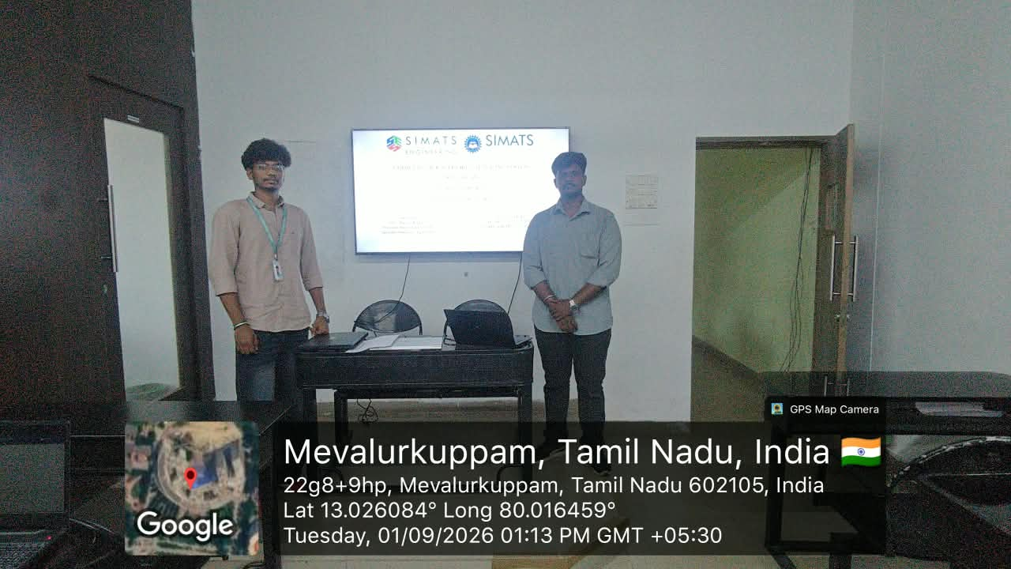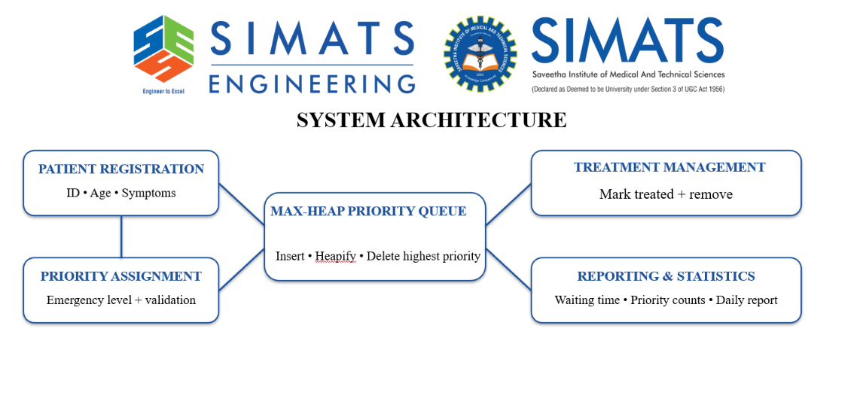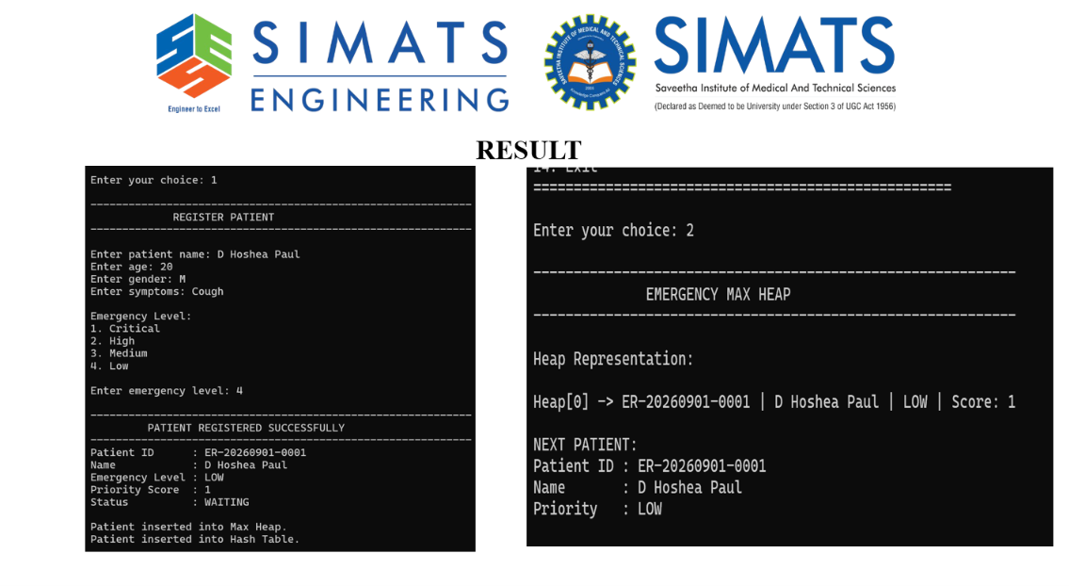
Project Description:
- Emergency Room Priority Handling System is a C-based application designed to schedule emergency patients according to their medical urgency rather than their arrival order.
- The system registers patient details such as Patient ID, age, and symptoms, and assigns a priority based on the emergency level.
- A Max-Heap priority queue is used to efficiently insert, organize, and retrieve patients, ensuring that the highest-priority patient is selected first.
- The system manages treatment status and waiting lists, while also calculating average waiting time and counting patients according to priority levels.
- The project generates and saves daily emergency reports, demonstrating how heaps and other fundamental data structures can improve emergency-room scheduling and priority management.

Student Signature Guide Signature

